**DAILY ONLINE ACTIVITIES SUMMARY**

|  |  |  |  |  |  |  |  |  |
| --- | --- | --- | --- | --- | --- | --- | --- | --- |
| **Date:** | **23-05-2020** | | | | | **Name:** | **Shiza Amreen.J** | |
| **Sem & Sec** | **4th sem B sec** | | | | | **USN:** | **4AL18CS078** | |
| **Online Test Summary** | | | | | | | | |
| **Subject** | | **Data Communication** | | | | | | |
| **Max. Marks** | | **30** | | **Score** | | | **26** | |
| **Certification Course Summary** | | | | | | | | |
| **Course** | **Python for Machine Learning** | | | | | | | |
| **Certificate Provider** | | | **GreatLearning** | | **Duration** | | | **5 Hours** |
| **Coding Challenges** | | | | | | | | |
| **Problem Statement:** Write a C Program to generate first N Triangular Numbers (Where N is Read from the Key board). | | | | | | | | |
| **Status: Completed** | | | | | | | | |
| **Uploaded the report in Github** | | | | | **yes** | | | |
| **If yes Repository name** | | | | | **Lockdown_Coding** | | | |
| **Uploaded the report in slack** | | | | | **yes** | | | |

Online Test Details:

Today we had Data Communication IA-1, I have attended the internal, and got 26 out of 30, and submitted it.

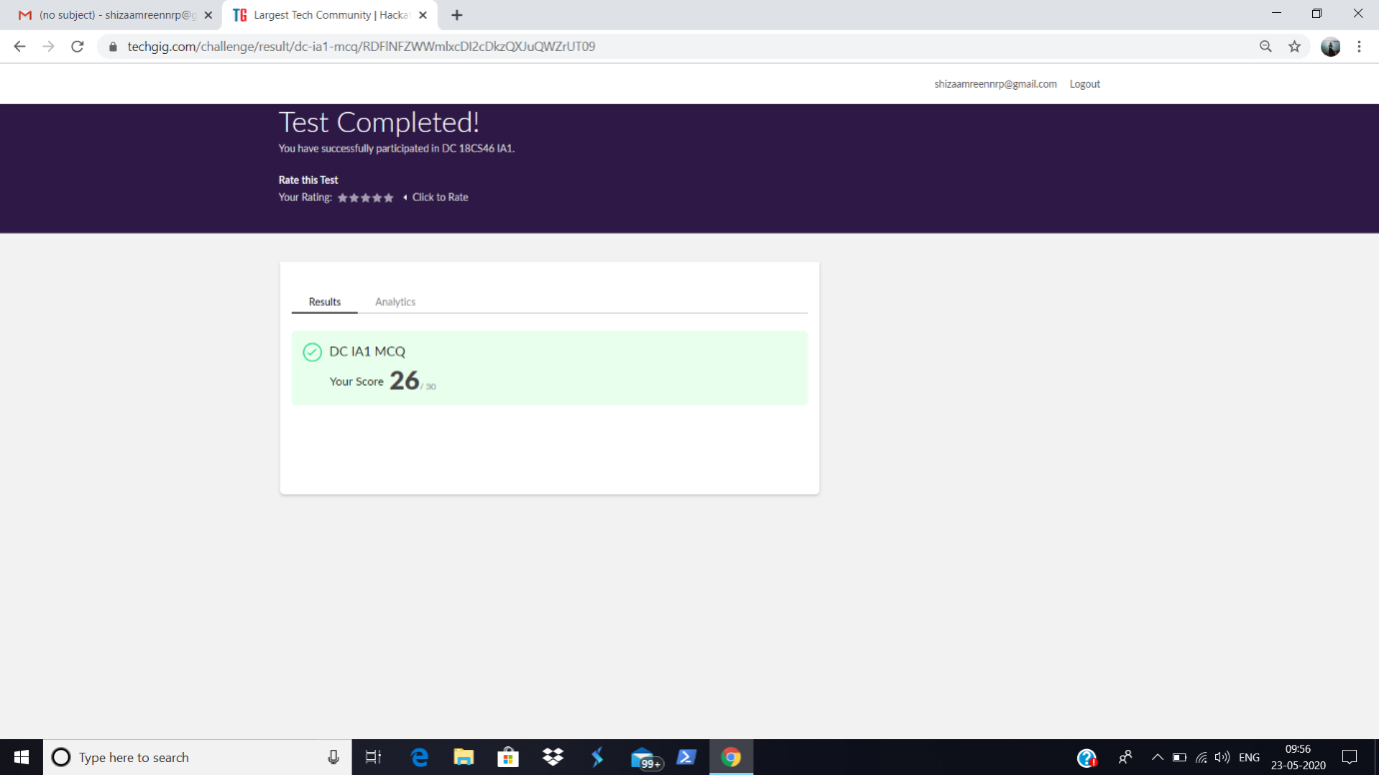

Certification Course Details:

As I have taken the course, Python for Machine Learning, in today’s session, I have gone through the Loops concept.

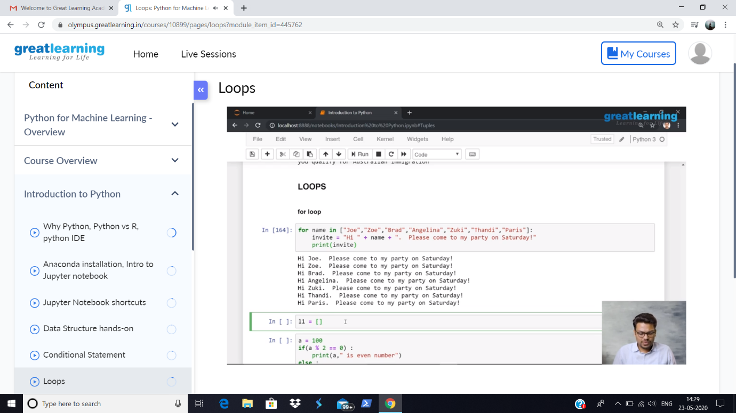

Coding Challenges Details:

**Problem Statement:** Write a C Program to generate first N Triangular Numbers (Where N is Read from the Key board).

I have written the code for the above problem statement and uploaded it in my github repository, Lockdown_Coding.

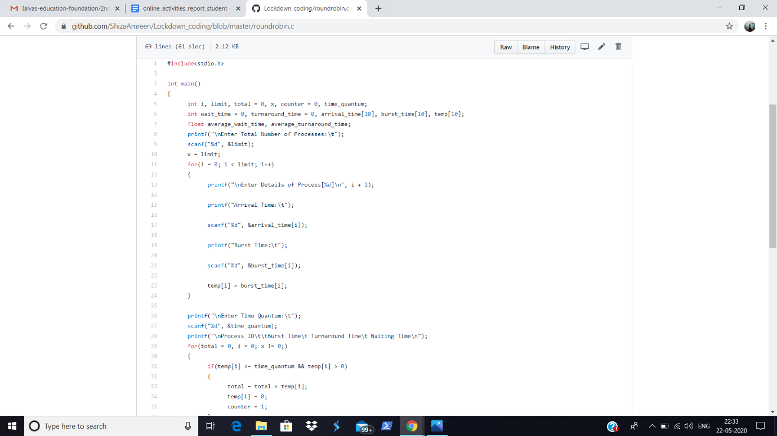

<https://github.com/ShizaAmreen/Lockdown_coding/commit/53feb305574ab2651557d5174c9c24e9ca7e5422>